Project Part 1 exam: Memory Management: Victim Replacement Algorithms

Instructions
- MAKE SURE TO USE THE EXAM VERSION OF THE SIMULATOR SimVictimExam.py
- EDIT THIS document to insert your answers
- Time: 40mins - Submit your completed document on the submission link provided. DO NOT submit a PDF.
- Where necessary copy and paste images of the data in question throughout your document to illustrate your answers.
- If necessary, re-run the program but make sure to show the new data in your answer.

Paste the ID and date and timestamp from the simulator here:
Thank you R00261559 of SD2A 20/10/2025, 09:49:04

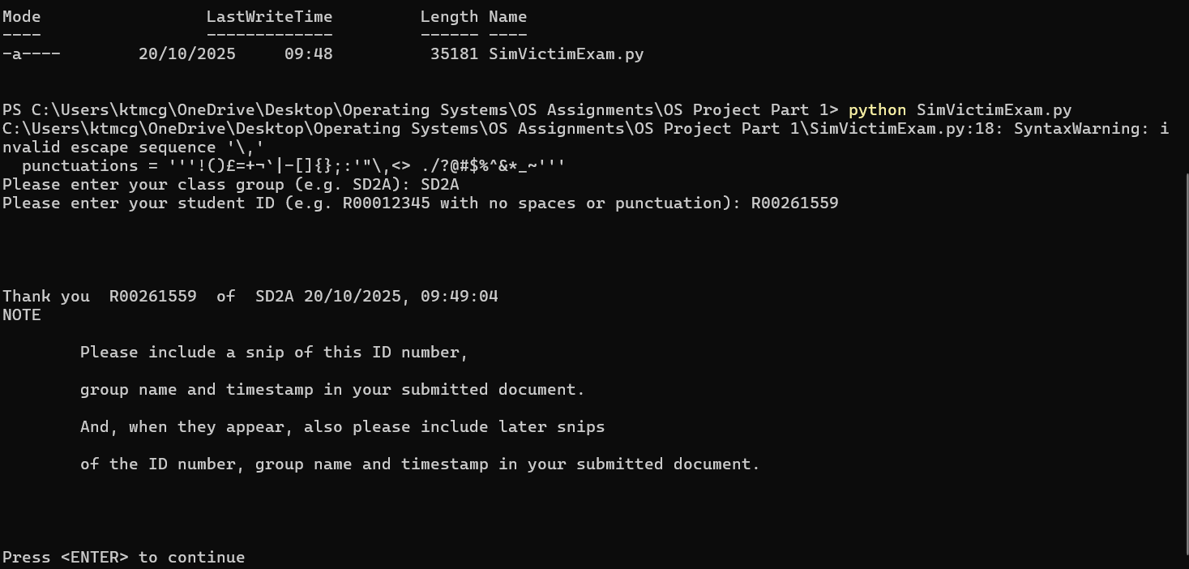

Answer both questions
Run each algorithm listed below in turn.
For each one, copy and paste ALL of the output and give the explanations indicated. NO OUTPUT = NO MARKS.
In all cases use examples from the data generated to illustrate your answers.
General explanations that do not refer to the data will receive ZERO MARKS.

- LRU (30 marks)
Copy and paste all of your output. (5 marks)

************** Least Recently Used **************

Reference recency summary, most recent page referenced is shown last: [115, 46, 69, 81, 84, 101, 114, 93, 52, 60, 98, 78, 999]

List of page numbers referenced before new page entered is as follows (most recent reference last):
[52, 98, 114, 69, 101, 115, 78, 84, 69, 78, 101, 78, 60, 93, 114, 101, 46, 78, 69, 81, 84, 93, 101, 114, 98, 78, 93, 114, 93, 78, 52, 60, 98, 78, 999]

There are 12 pages in RAM (assume RAM is now full)

Frames in SD2A R00261559 memory are shown in frame number order.

Frames in SD2A R00261559 20/10/2025, 10:04:29 memory before victim replacement were:
Frame Page arrival time reference bit modify bit reference counter
0 52 0 1 0 2 = 00000010
1 98 1 1 0 3 = 00000011
2 114 2 0 1 4 = 00000100
3 69 3 0 1 3 = 00000011
4 101 4 0 0 4 = 00000100
5 115 5 0 0 1 = 00000001
6 78 6 1 0 7 = 00000111
7 84 7 0 1 2 = 00000010
8 60 12 1 0 2 = 00000010
9 93 13 0 0 4 = 00000100
10 46 16 0 0 1 = 00000001
11 81 19 0 0 1 = 00000001
Press <ENTER> to see which page was choosen as victim...

SD2A R00261559 Victim chosen was: page 115 at 20/10/2025, 10:04:29

Page 999 was inserted instead, so:

Frames in memory are now:
Frame Page arrival time reference bit modify bit reference counter
0 52 0 1 0 2 = 00000010
1 98 1 1 0 3 = 00000011
2 114 2 0 1 4 = 00000100
3 69 3 0 1 3 = 00000011
4 101 4 0 0 4 = 00000100
5 999 34 1 0 1 = 00000001
6 78 6 1 0 7 = 00000111
7 84 7 0 1 2 = 00000010
8 60 12 1 0 2 = 00000010
9 93 13 0 0 4 = 00000100
10 46 16 0 0 1 = 00000001
11 81 19 0 0 1 = 00000001
Fully explain in detail why the victim chosen was picked with reference to the specific data used. (25 marks)

- LRU (Least Recently Used) evicts the page that was accessed the longest time ago. Page 115 was accessed the longest time ago due to the recency summary (at the beginning of the list). The sim correctly chose Page 115 as the victim and replaced it with Page 100.

2. LRU Ageing (70 marks)
Copy and paste all of your output. (15 marks)

************** Least Recently Used with Ageing**************

First we will show the ageing history
Press <ENTER> to continue to the history
Reference counter ageing history
In 5 references up to time 5 the pages referenced pages were: [52, 98, 114, 69, 101]
And all references so far are: [52, 98, 114, 69, 101]

After 1 ageing (s) the current reference history is:
Frame Page Reference count Reference History Byte Reference bit
0 52 1 10000000 =128 1
1 98 1 10000000 =128 1
2 114 1 10000000 =128 1
3 69 1 10000000 =128 1
4 101 1 10000000 =128 1
5 115 0 00000000 =0 0
6 78 0 00000000 =0 0
7 84 0 00000000 =0 0
8 60 0 00000000 =0 0
9 93 0 00000000 =0 0
10 46 0 00000000 =0 0
11 81 0 00000000 =0 0
Press <ENTER> to continue to next part of the history
In 5 references up to time 10 the pages referenced pages were: [115, 78, 84, 69, 78]
And all references so far are: [52, 98, 114, 69, 101] [115, 78, 84, 69, 78]

After 2 ageing (s) the current reference history is:
Frame Page Reference count Reference History Byte Reference bit
0 52 1 01000000 =64 0
1 98 1 01000000 =64 0
2 114 1 01000000 =64 0
3 69 2 11000000 =192 1
4 101 1 01000000 =64 0
5 115 1 10000000 =128 1
6 78 2 10000000 =128 1
7 84 1 10000000 =128 1
8 60 0 00000000 =0 0
9 93 0 00000000 =0 0
10 46 0 00000000 =0 0
11 81 0 00000000 =0 0
Press <ENTER> to continue to next part of the history
In 5 references up to time 15 the pages referenced pages were: [101, 78, 60, 93, 114]
And all references so far are: [52, 98, 114, 69, 101] [115, 78, 84, 69, 78] [101, 78, 60, 93, 114]

After 3 ageing (s) the current reference history is:
Frame Page Reference count Reference History Byte Reference bit
0 52 1 00100000 =32 0
1 98 1 00100000 =32 0
2 114 2 10100000 =160 1
3 69 2 01100000 =96 0
4 101 2 10100000 =160 1
5 115 1 01000000 =64 0
6 78 3 11000000 =192 1
7 84 1 01000000 =64 0
8 60 1 10000000 =128 1
9 93 1 10000000 =128 1
10 46 0 00000000 =0 0
11 81 0 00000000 =0 0
Press <ENTER> to continue to next part of the history
In 5 references up to time 20 the pages referenced pages were: [101, 46, 78, 69, 81]
And all references so far are: [52, 98, 114, 69, 101] [115, 78, 84, 69, 78] [101, 78, 60, 93, 114] [101, 46, 78, 69, 81]

After 4 ageing (s) the current reference history is:
Frame Page Reference count Reference History Byte Reference bit
0 52 1 00010000 =16 0
1 98 1 00010000 =16 0
2 114 2 01010000 =80 0
3 69 3 10110000 =176 1
4 101 3 11010000 =208 1
5 115 1 00100000 =32 0
6 78 4 11100000 =224 1
7 84 1 00100000 =32 0
8 60 1 01000000 =64 0
9 93 1 01000000 =64 0
10 46 1 10000000 =128 1
11 81 1 10000000 =128 1
Press <ENTER> to continue to next part of the history
In 5 references up to time 25 the pages referenced pages were: [84, 93, 101, 114, 98]
And all references so far are: [52, 98, 114, 69, 101] [115, 78, 84, 69, 78] [101, 78, 60, 93, 114] [101, 46, 78, 69, 81] [84, 93, 101, 114, 98]

After 5 ageing (s) the current reference history is:
Frame Page Reference count Reference History Byte Reference bit
0 52 1 00001000 =8 0
1 98 2 10001000 =136 1
2 114 3 10101000 =168 1
3 69 3 01011000 =88 0
4 101 4 11101000 =232 1
5 115 1 00010000 =16 0
6 78 4 01110000 =112 0
7 84 2 10010000 =144 1
8 60 1 00100000 =32 0
9 93 2 10100000 =160 1
10 46 1 01000000 =64 0
11 81 1 01000000 =64 0
Press <ENTER> to continue to next part of the history
In 5 references up to time 30 the pages referenced pages were: [78, 93, 114, 93, 78]
And all references so far are: [52, 98, 114, 69, 101] [115, 78, 84, 69, 78] [101, 78, 60, 93, 114] [101, 46, 78, 69, 81] [84, 93, 101, 114, 98] [78, 93, 114, 93, 78]

After 6 ageing (s) the current reference history is:
Frame Page Reference count Reference History Byte Reference bit
0 52 1 00000100 =4 0
1 98 2 01000100 =68 0
2 114 4 11010100 =212 1
3 69 3 00101100 =44 0
4 101 4 01110100 =116 0
5 115 1 00001000 =8 0
6 78 6 10111000 =184 1
7 84 2 01001000 =72 0
8 60 1 00010000 =16 0
9 93 4 11010000 =208 1
10 46 1 00100000 =32 0
11 81 1 00100000 =32 0
Press <ENTER> to continue to next part of the history
In 5 references up to time 34 the pages referenced pages were: [52, 60, 98, 78]
And all references so far are: [52, 98, 114, 69, 101] [115, 78, 84, 69, 78] [101, 78, 60, 93, 114] [101, 46, 78, 69, 81] [84, 93, 101, 114, 98] [78, 93, 114, 93, 78] [52, 60, 98, 78]

After 7 ageing (s) the current reference history is:
Frame Page Reference count Reference History Byte Reference bit
0 52 2 10000010 =130 1
1 98 3 10100010 =162 1
2 114 4 01101010 =106 0
3 69 3 00010110 =22 0
4 101 4 00111010 =58 0
5 115 1 00000100 =4 0
6 78 7 11011100 =220 1
7 84 2 00100100 =36 0
8 60 2 10001000 =136 1
9 93 4 01101000 =104 0
10 46 1 00010000 =16 0
11 81 1 00010000 =16 0
Press <ENTER> to continue to next part of the history

Reference recency summary, most recent page referenced is shown last: [115, 46, 69, 81, 84, 101, 114, 93, 52, 60, 98, 78, 999]

List of page numbers referenced before new page entered is as follows (most recent reference last):
[52, 98, 114, 69, 101, 115, 78, 84, 69, 78, 101, 78, 60, 93, 114, 101, 46, 78, 69, 81, 84, 93, 101, 114, 98, 78, 93, 114, 93, 78, 52, 60, 98, 78, 999]

There are 12 pages in RAM (assume RAM is now full)

Frames in SD2A R00261559 memory are shown in frame number order.

Frames in SD2A R00261559 20/10/2025, 10:10:30 memory before victim replacement were:
Frame Page arrival time reference bit modify bit reference counter reference history
0 52 0 1 0 2 = 00000010 10000010 = 130
1 98 1 1 0 3 = 00000011 10100010 = 162
2 114 2 0 1 4 = 00000100 01101010 = 106
3 69 3 0 1 3 = 00000011 00010110 = 22
4 101 4 0 0 4 = 00000100 00111010 = 58
5 115 5 0 0 1 = 00000001 00000100 = 4
6 78 6 1 0 7 = 00000111 11011100 = 220
7 84 7 0 1 2 = 00000010 00100100 = 36
8 60 12 1 0 2 = 00000010 10001000 = 136
9 93 13 0 0 4 = 00000100 01101000 = 104
10 46 16 0 0 1 = 00000001 00010000 = 16
11 81 19 0 0 1 = 00000001 00010000 = 16
Press <ENTER> to see which page was choosen as victim...

SD2A R00261559 Victim chosen was: page 115 at 20/10/2025, 10:10:30

Page 999 was inserted instead, so:

Frames in memory are now:
Frame Page arrival time reference bit modify bit reference counter reference history
0 52 0 1 0 2 = 00000010 10000010 = 130
1 98 1 1 0 3 = 00000011 10100010 = 162
2 114 2 0 1 4 = 00000100 01101010 = 106
3 69 3 0 1 3 = 00000011 00010110 = 22
4 101 4 0 0 4 = 00000100 00111010 = 58
5 999 34 1 0 1 = 00000001 10000000 = 128
6 78 6 1 0 7 = 00000111 11011100 = 220
7 84 7 0 1 2 = 00000010 00100100 = 36
8 60 12 1 0 2 = 00000010 10001000 = 136
9 93 13 0 0 4 = 00000100 01101000 = 104
10 46 16 0 0 1 = 00000001 00010000 = 16
11 81 19 0 0 1 = 00000001 00010000 = 16

- Fully explain why the chosen victim was selected with reference to the specific data used. (20 marks)
  - LRU Ageing approximates the exact LRU by keeping an age byte for each page, with a larger byte meaning that the page was referenced more recently. LRU Ageing evicts the page with the smallest age byte/referenced the longest ago. Page 115 was the victim again, as it had the smallest byte size (4).

- Fully explain the meaning of the reference history byte values as used in LRU Ageing using three examples from your data.
(15 marks)
  - The reference byte represented the age of the page, or how long ago it was last referenced. The bigger the byte, the more recently it was referenced. The leftmost bit represented the most recent reference, and the rightmost bit is the oldest.
    - Page 115 had an age byte size of 4 and was deemed the least recently used page.
    - Both Page 46 and Page 81 had an age byte size of 16, making them the second-least recently used pages.
    - Page 78 is the most recently referenced page with an age byte size of 220.

- Fully explain how the ageing of the reference history byte works using an example from your output after 3 ageing. (20 marks)
  - After each aging step the history bit for a page is shifted to the right by one bit. This is how the older bits are aged. The current reference bit is moved to the most significant bit, and the reference bit is cleared for the next interval.
  - After 3 Ageing’s, Page 114’s history byte changes from 01000000 to 00100000, by shifting right by 1, and is inserted at the MSB (10100000 – 160). The reference bit then gets cleared for the next interval. This shows that Page 114 was recently referenced.

